MUSYATI
Tracking Monitor
BATCHING PLANT OPERATIONS
User Manual
Concrete Sales · Production · Materials · Machinery · Manpower · Costing · Projects
Version 1.0
June 2026

Contents

1. Introduction
The Musyati Tracking Monitor is a web-based dashboard for running concrete batching-plant operations. It replaces scattered spreadsheets with one connected system that records concrete sales, daily production, materials, machinery, manpower, monthly costing, and the wider projects your concrete supplies.
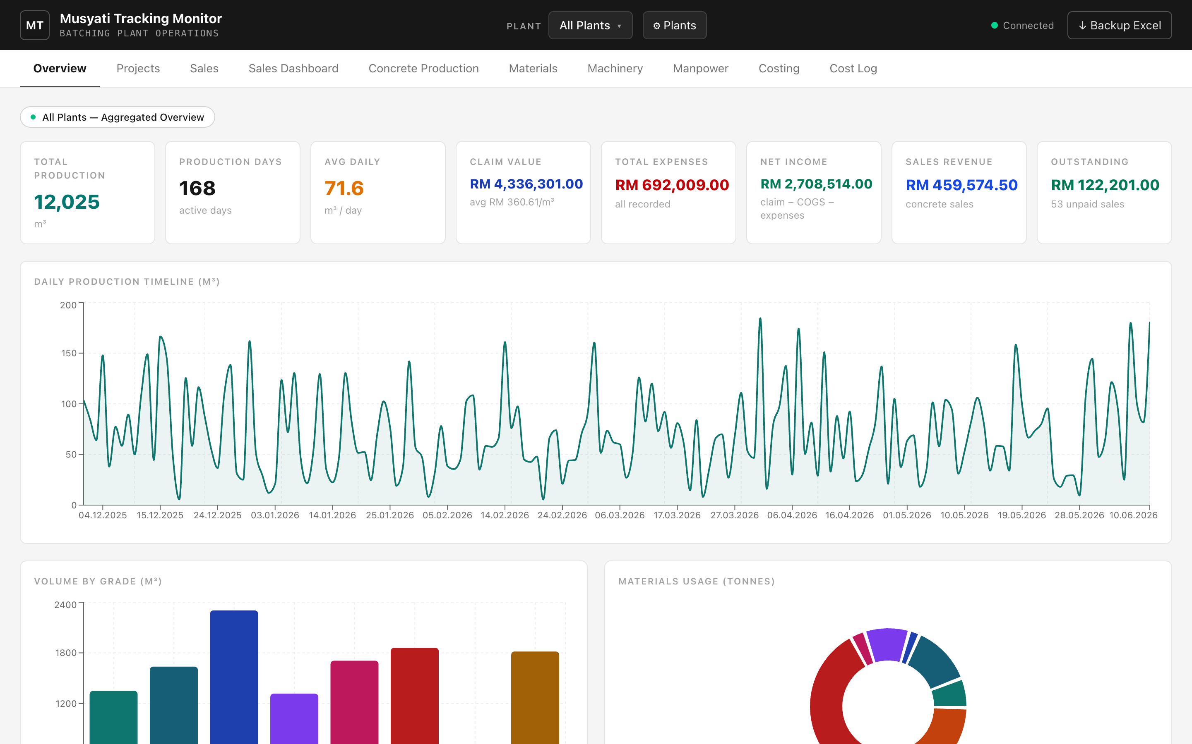
The Overview page — the dashboard you see when the app opens.
Key idea: every figure you see is calculated live from the records you enter. Totals, balances, profit and progress are never typed in by hand — so the numbers always agree with each other and the "wrong total" problems of manual spreadsheets disappear.

What makes it different
- One source of truth. All data lives in a single Excel workbook the system manages for you. You can open or back it up anytime.
- Always-correct maths. Sale totals, running balances, COGS, net income, project progress and wages are all computed automatically.
- Multi-plant. Track several batching plants separately or combine them into one aggregated view with a single click.
- Linked records. Sales, production and expenses can be tagged to a project so you see true per-project cost and profit.

Who this manual is for
Plant administrators and office staff who enter daily records, and managers who read the dashboards. No technical background is needed — if you can use a spreadsheet, you can use this.

2. Getting Started

2.1 Starting the application
- Double-click launch-musyati.command in the musyati-dashboard folder.
- A small black window opens and starts the system. The first launch takes a minute or two (one-time setup); after that it is a few seconds.
- Your web browser opens automatically to the dashboard.

Keep the black window open
That window is the engine running the dashboard. Closing it (or pressing Ctrl-C) shuts the system down. Re-open it anytime by double-clicking the launcher again.

2.2 Opening the dashboard in a browser
While the system is running, the dashboard is available at this address on the same computer:
http://localhost:4000
Bookmark it for quick access. You can also paste it into any browser tab.

2.3 The screen at a glance
- Dark header (top). Company name, the Plant selector, the Plants manager (⚙ Plants), a connection light, and the Backup Excel button.
- Tab bar. Switches between the ten sections (Overview, Projects, Sales, and so on).
- Scope chip. A small pill under the tabs showing which plant(s) you are currently viewing.
- Connection light. Green "Connected" means all is well; amber/red means the engine window is not running — re-open the launcher.

3. Core Concepts

3.1 The plant selector
Most sections respond to the Plant selector in the header. Click it to choose:
- All Plants — Aggregated. Combines every plant into one view (totals add up across plants).
- A single plant. Shows just that plant. Some entry screens (like typing into the production grid, or editing costing) require a single plant to be selected so the system knows where the record belongs.
- Several plants. Tick a custom combination to compare a subset.

3.2 Adding, editing and deleting records
- Add. Look for the dark "+ Add…" button at the top-right of a section. A dialog opens; fill it in and save.
- Edit. Click "Edit" at the end of any row.
- Delete. Click "Delete" and confirm. The system blocks deletes that would break links — for example, you cannot delete a company while it still has sales, or a project while records are tagged to it.

3.3 Sorting and scrolling tables
- Sortable columns. On the Sales table, click a column header to sort; click again to reverse. Arrows (▲ ▼) show the active column.
- Fixed-height tables. Long logs scroll inside their box with the header staying in place, so the page layout never stretches as data grows.

3.4 Your data and backups
- Where it lives. Everything is stored in server/data/musyati-data.xlsx.
- Automatic backups. A timestamped copy is saved every time you make a change, kept in server/data/backups/.
- Manual backup. Click Backup Excel (top-right) anytime to download a dated copy of the whole workbook.

4. The Sections
The dashboard has ten tabs. Here is what each one is for:
Tab | Purpose
Overview | Top-level KPIs and charts for the selected plant(s).
Projects | Portfolio of works (bridges, roads, drains…) with progress and per-project financials.
Sales | Concrete sales records with paid/unpaid totals and sorting.
Sales Dashboard | Financial analytics: profit, projection, receivables aging, unit economics.
Concrete Production | Daily pour volumes by grade, in an Excel-style monthly grid.
Materials | Material balances and usage/received/transfer transactions.
Machinery | Machine register and maintenance log.
Manpower | Worker register, attendance and estimated wages.
Costing | Monthly profit-and-loss per plant.
Cost Log | The list of individual expenses that feed Costing.

5. Overview
The landing page. It summarises the selected plant(s) with eight KPI cards and three charts. Everything here is read-only — it reflects the records entered in the other sections.

KPI cards
Card | How it is calculated
Total Production | Sum of all pour volumes (m³).
Production Days | Number of distinct days with a pour.
Avg Daily | Total production ÷ production days.
Claim Value | Monthly production × claim price, summed.
Total Expenses | Sum of all expenses recorded.
Net Income | Claim value − COGS − expenses.
Sales Revenue | Sum of all concrete sale totals.
Outstanding | Unpaid sales total, with invoice count.

Charts: Daily Production Timeline (volume over time), Volume by Grade, and Materials Usage.

6. Projects
Tracks the works your plants supply concrete to — bridges, road maintenance, drainage, buildings, and so on. A project is led by a client and may be served by one or more plants.
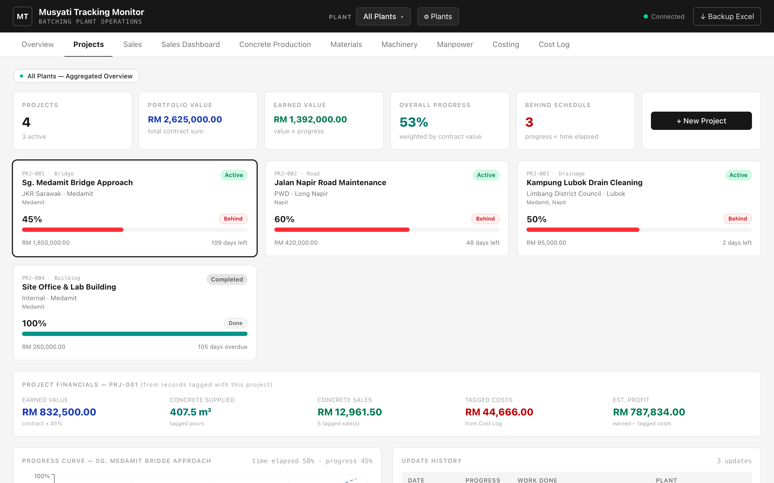
Projects — portfolio cards, progress curve and the per-project financials strip.

6.1 Creating a project
- Click + New Project.
- Fill in code, name, type, client, location, contract value, start and target-completion dates, status, and tick the plant(s) involved.
- Save. The project appears as a card.

6.2 Recording progress
Progress is a dated history, not a single number. Click a project card, then "+ Update Progress" and enter the total percentage complete on that date (a slider plus a number box). The newest entry becomes the current progress.

6.3 What the page shows
- Portfolio KPIs. Project count, total contract value, earned value, weighted overall progress, and how many are behind schedule.
- Project cards. Each shows current %, a schedule-health chip (Ahead / On Track / Behind / Done), contract value and days remaining.
- Progress Curve. Actual progress against a straight "planned" line from start to target date.
- Project Financials strip. For the selected project: earned value, concrete supplied (m³), concrete sales, tagged costs, and estimated profit.

Tagging makes the financials work
On the Sales, Concrete Production and Cost Log entry forms there is an optional Project field. Tagging a record to a project is what lets the Project Financials strip show real concrete supplied, sales and costs for that job. Untagged records are treated as general / overhead.

6.4 Key terms
Term | Meaning
Contract value | The agreed total price of the project (you enter this).
Earned value | Contract value × current progress %.
Schedule health | Compares progress % against the % of contract time already elapsed.
Estimated profit | Earned value − costs tagged to the project.

7. Sales
Records every concrete sale (delivery order) and tracks who has paid.
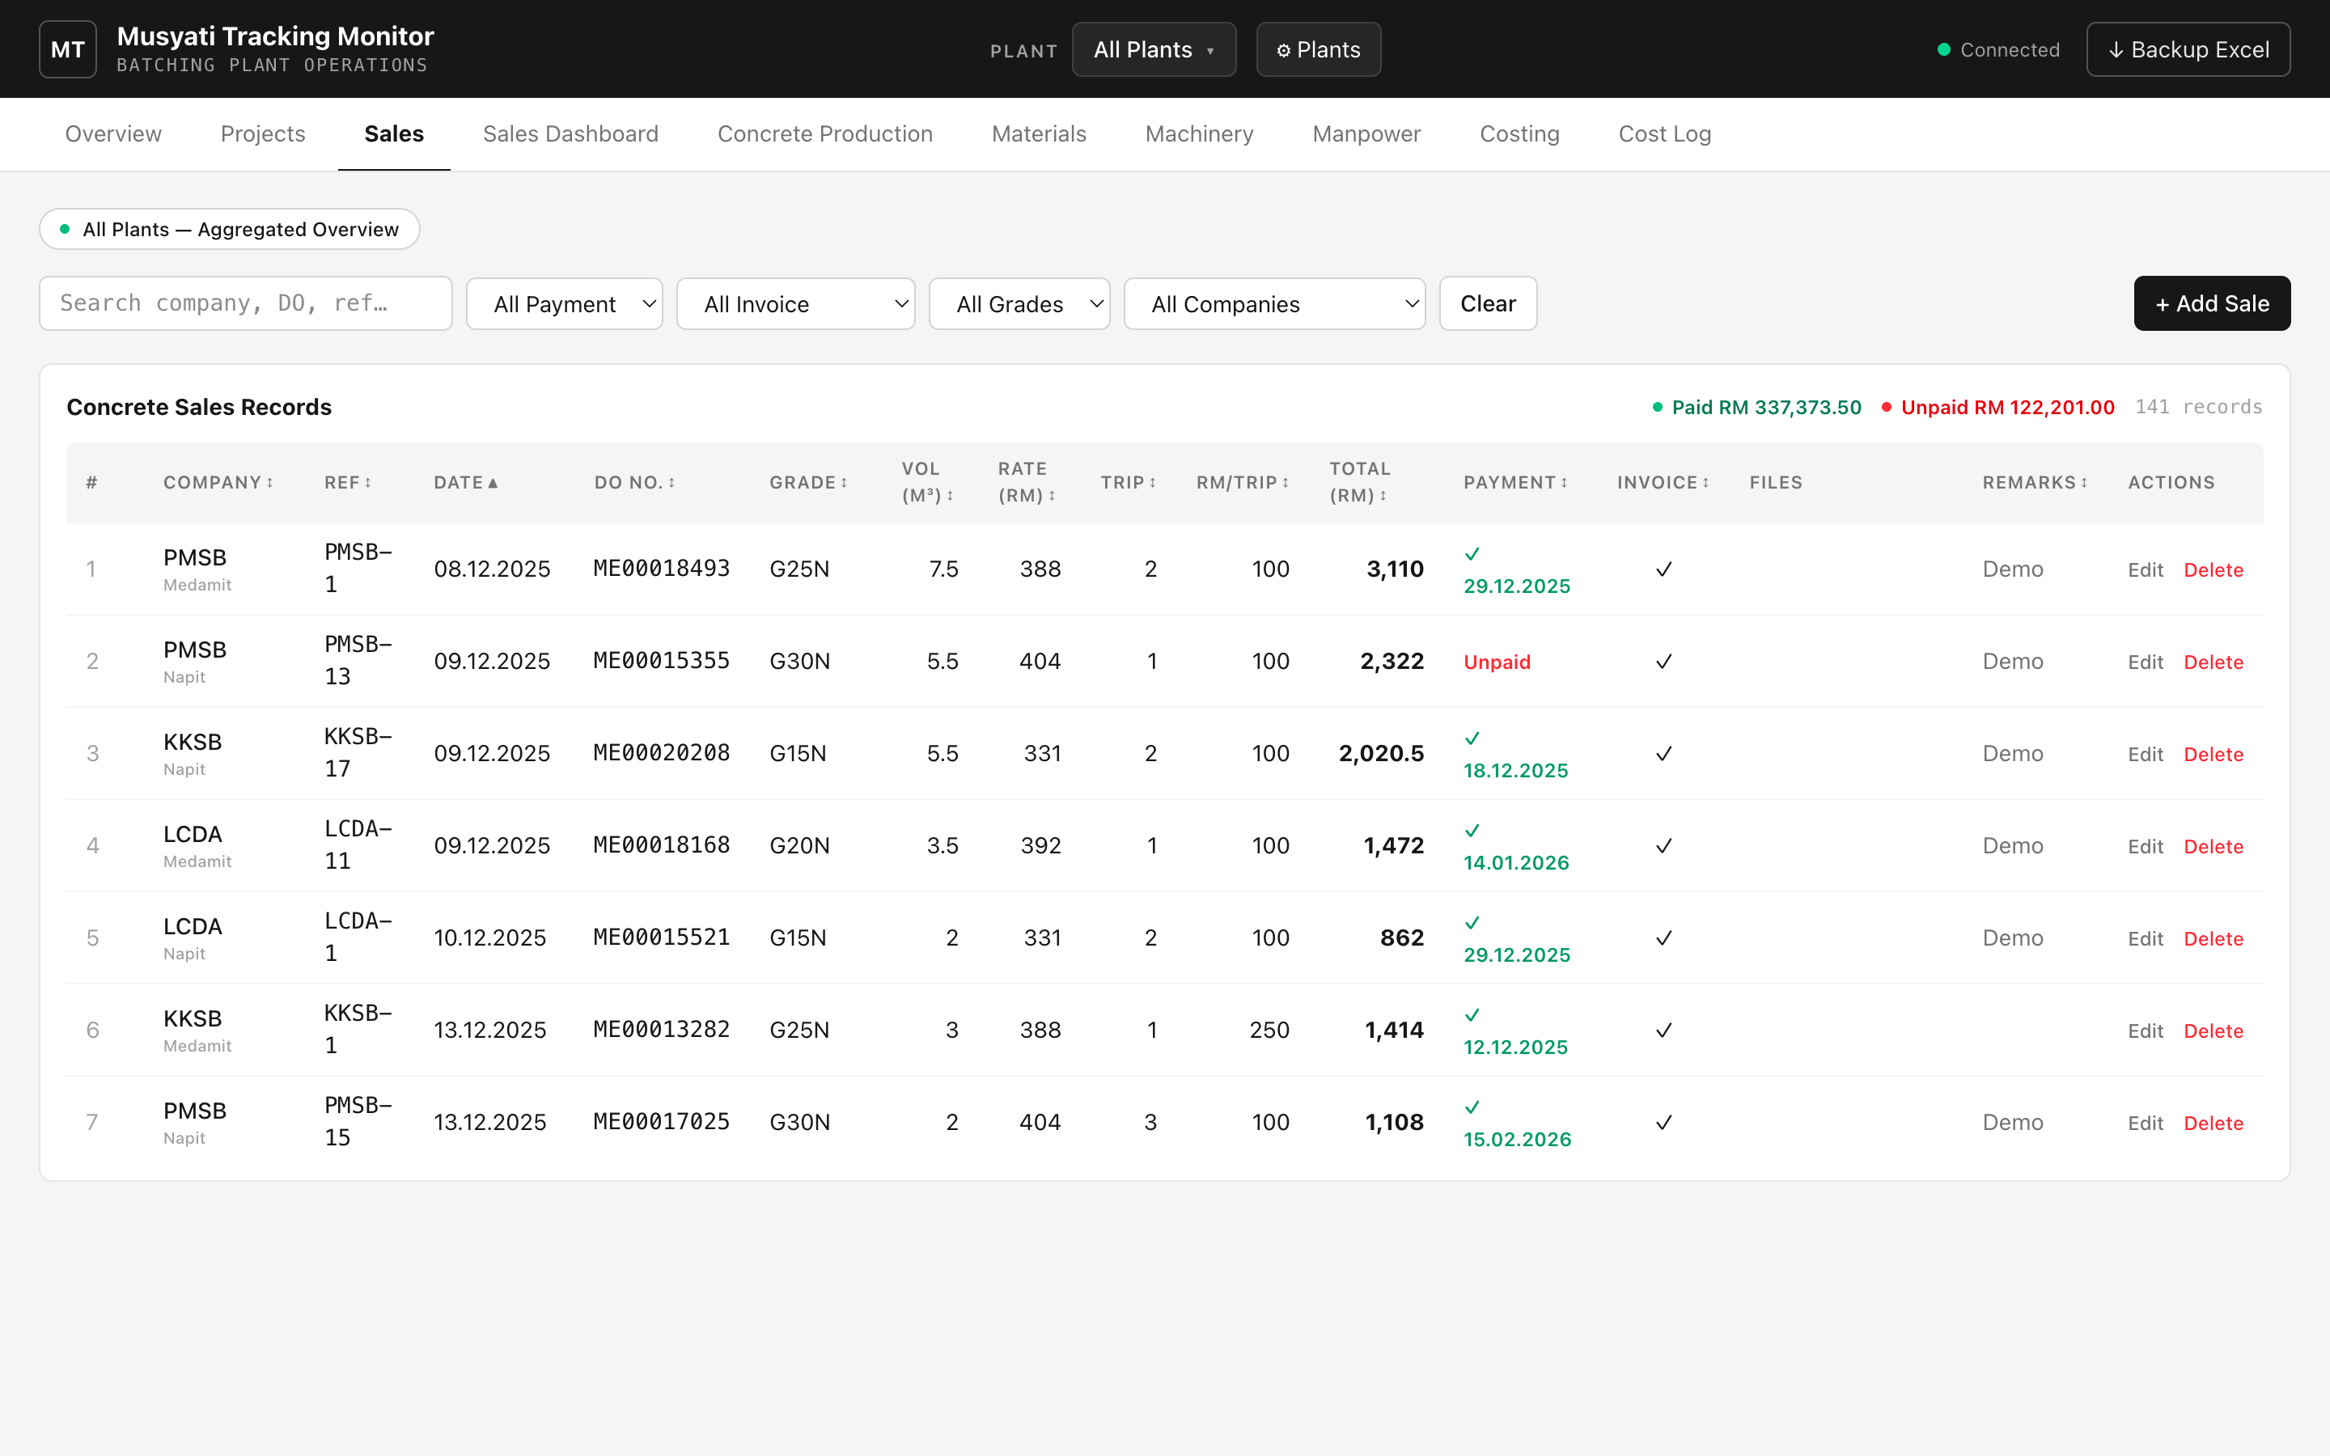
Sales — paid/unpaid totals (top-right), filters and sortable columns.

7.1 Adding a sale
- Click + Add Sale.
- Choose the plant, company, grade and (optionally) a project. To add a customer that does not exist yet, pick ＋ Add new company… in the Company list and type the name.
- Enter volume, rate, trips and RM/trip. The Total is calculated for you as volume × rate + trips × RM/trip.
- Tick Payment received (and set the payment date) and Invoice issued as appropriate.
- Optionally attach files (DO scans, invoices) in the Attachments area, then save.

7.2 Reading the table
- Paid / Unpaid totals. Top-right of the table, in green and red. They sum whatever rows are currently shown, so they react to every filter — filter to one company to see exactly what that customer owes.
- Filters. Search box plus dropdowns for payment status, invoice status, grade and company. "Clear" resets them.
- Sorting. Click any column header to sort; click again to reverse.
- Attachments. The Files column shows clickable links to uploaded documents.

How the total is worked out
Total = Volume × Rate + Trips × RM/Trip
Example: 3.5 m³ × RM417 + 1 trip × RM100 = RM1,559.50.

8. Sales Dashboard
Turns the sales (and costing) records into financial analytics. Like Overview, it is read-only and respects the plant selector.
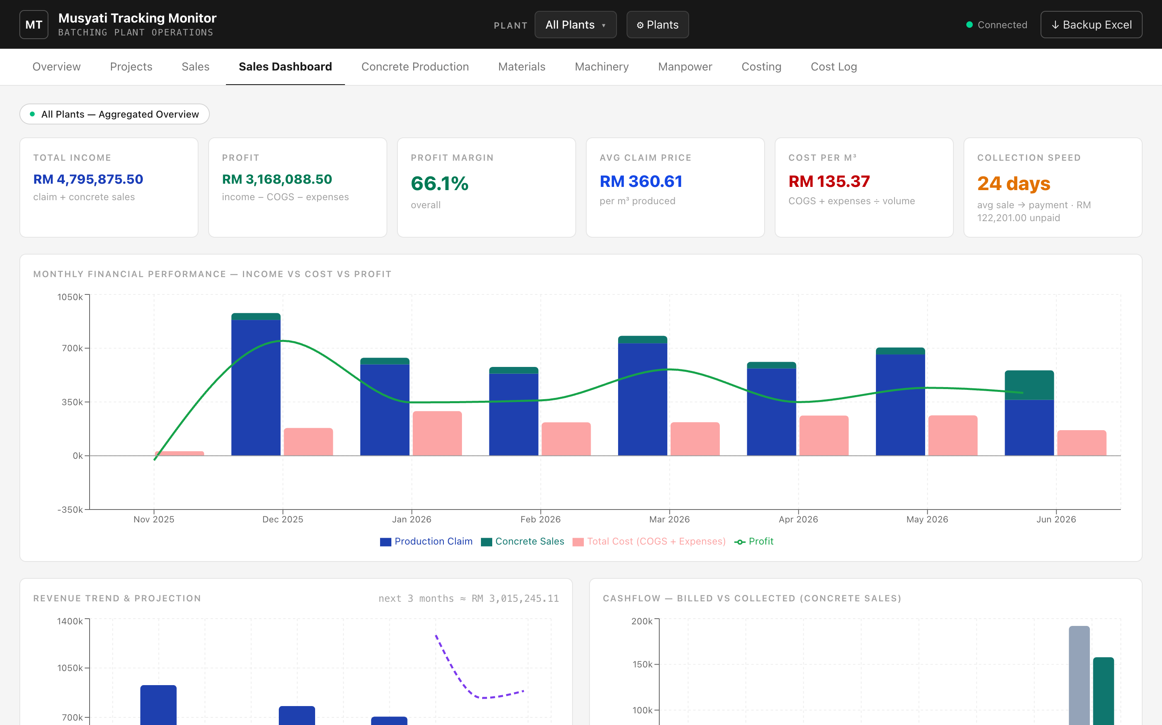
Sales Dashboard — profitability, projection, cashflow and receivables aging.
Chart / KPI | What it tells you
Total Income / Profit / Margin | Claim + concrete sales, less COGS and expenses.
Avg Claim Price & Cost per m³ | Unit economics — what you charge vs. what it costs to make a cube.
Collection Speed (DSO) | Average days from sale to payment.
Monthly Financial Performance | Income vs. cost vs. profit, month by month.
Revenue Trend & Projection | Historical income with a forward trend estimate.
Cashflow: Billed vs Collected | Where invoices raised are still being chased.
Receivables Aging | Who owes what, split into 0–30 / 31–60 / 60+ day buckets.
Unit Economics | Claim price vs. cost per m³ over time (the gap is your margin).
Customers | Revenue and outstanding exposure per company.

Note on the projection
The revenue projection is a simple straight-line trend, useful as a guide. With only a few months of history it will shift as more real data is entered.

9. Concrete Production
Records daily pour volumes by grade, laid out exactly like the monthly Excel summary (days down the side, grades across the top, with a TOTAL row).
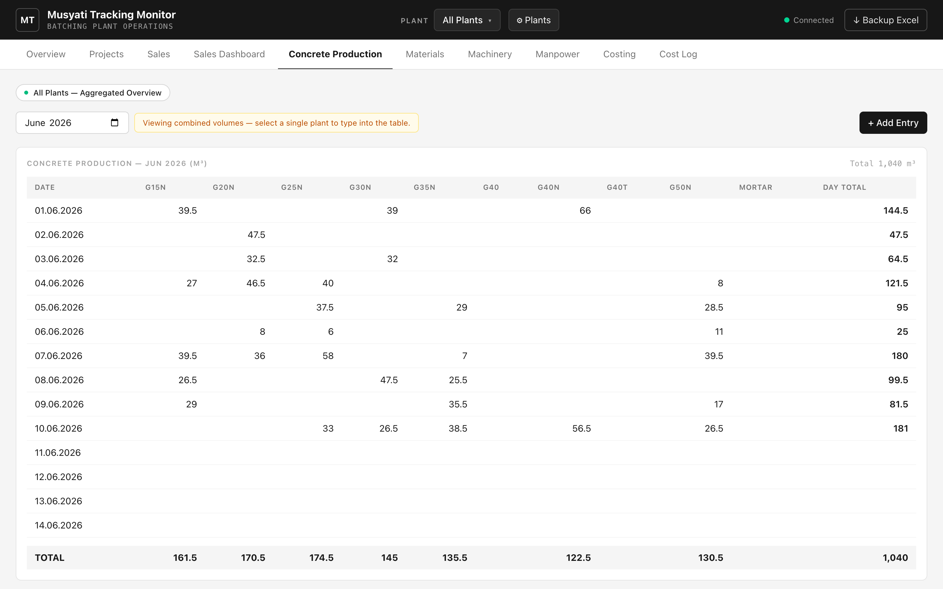
Concrete Production — the Excel-style monthly grid with a TOTAL row.

9.1 Typing straight into the grid
With a single plant selected, every cell is editable. Click a cell, type the m³ for that day and grade, and press Tab or click away — it saves instantly. Clear a cell to remove that entry. The Day Total and monthly TOTAL update automatically.
With multiple plants selected the grid is read-only (combined view) — choose one plant to edit.

9.2 Adding via the form
Click + Add Entry to record a whole day at once: pick the date and optional project, then type a volume against any grades that apply. Use the month picker to move between months.

10. Materials
Tracks material stock (cement/PLC, sand, aggregates, admixtures, etc.). Materials are shared across all plants; only the transactions are plant-specific.
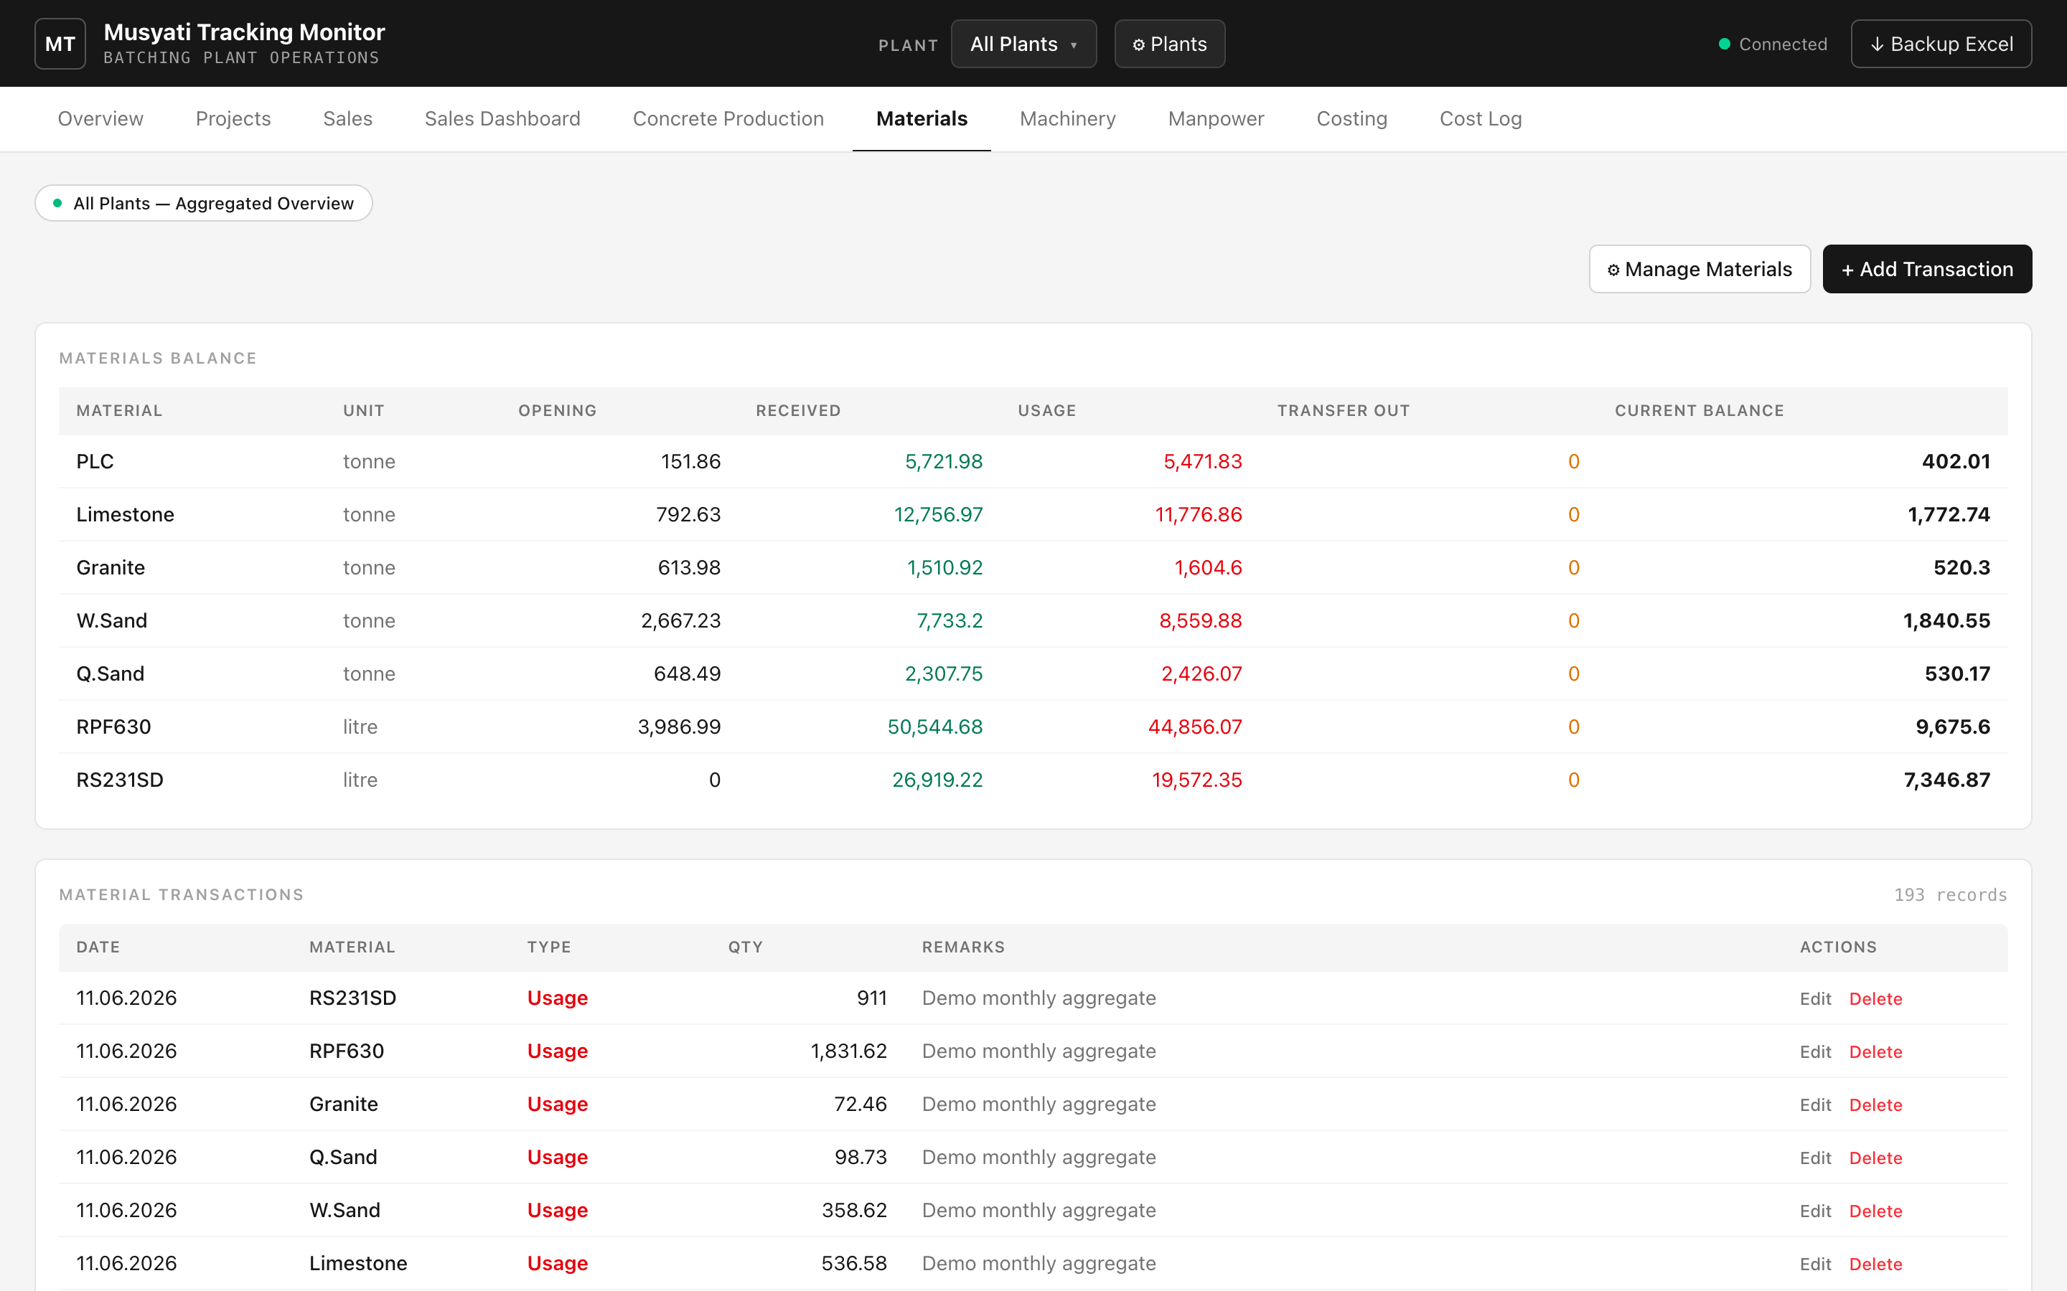
Materials — current balances above, the transaction log below.

10.1 Balances
The top table shows, per material: opening balance, total received, total used, transfers out, and the current balance (opening + received − usage − transfers).

10.2 Recording a transaction
- Click + Add Transaction.
- Choose plant, material, date, and type — Usage, Received or Transfer Out — then the quantity.
- Save. Balances recalculate immediately.
Use ⚙ Manage Materials to add a new material or set its opening balance.

11. Machinery
A register of plant and equipment with a maintenance log.
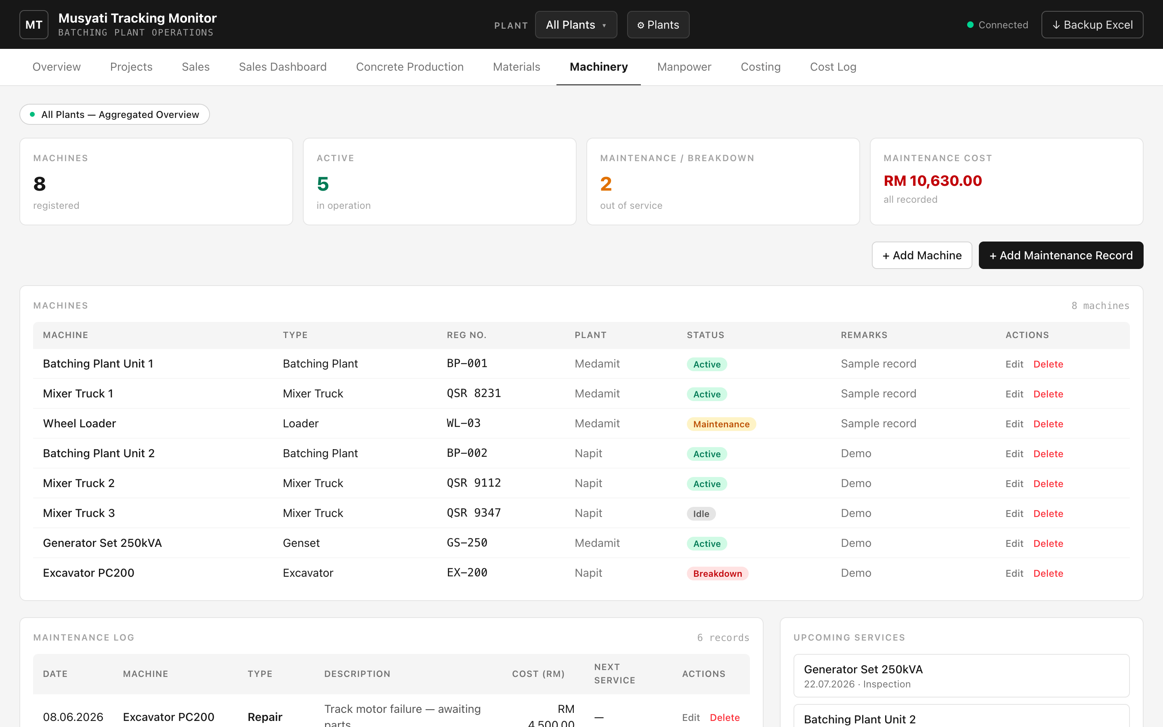
Machinery — register, maintenance log and upcoming services.
- Machines. Name, type, registration number, owning plant, and status (Active / Maintenance / Breakdown / Idle).
- Maintenance Log. Each service, repair or inspection with its cost and an optional next-service date.
- Upcoming Services. Automatically lists machines with a future service date so nothing is missed.
- KPIs. Total machines, active count, how many are down, and total maintenance cost.

12. Manpower
A worker register plus daily attendance, with estimated wages.
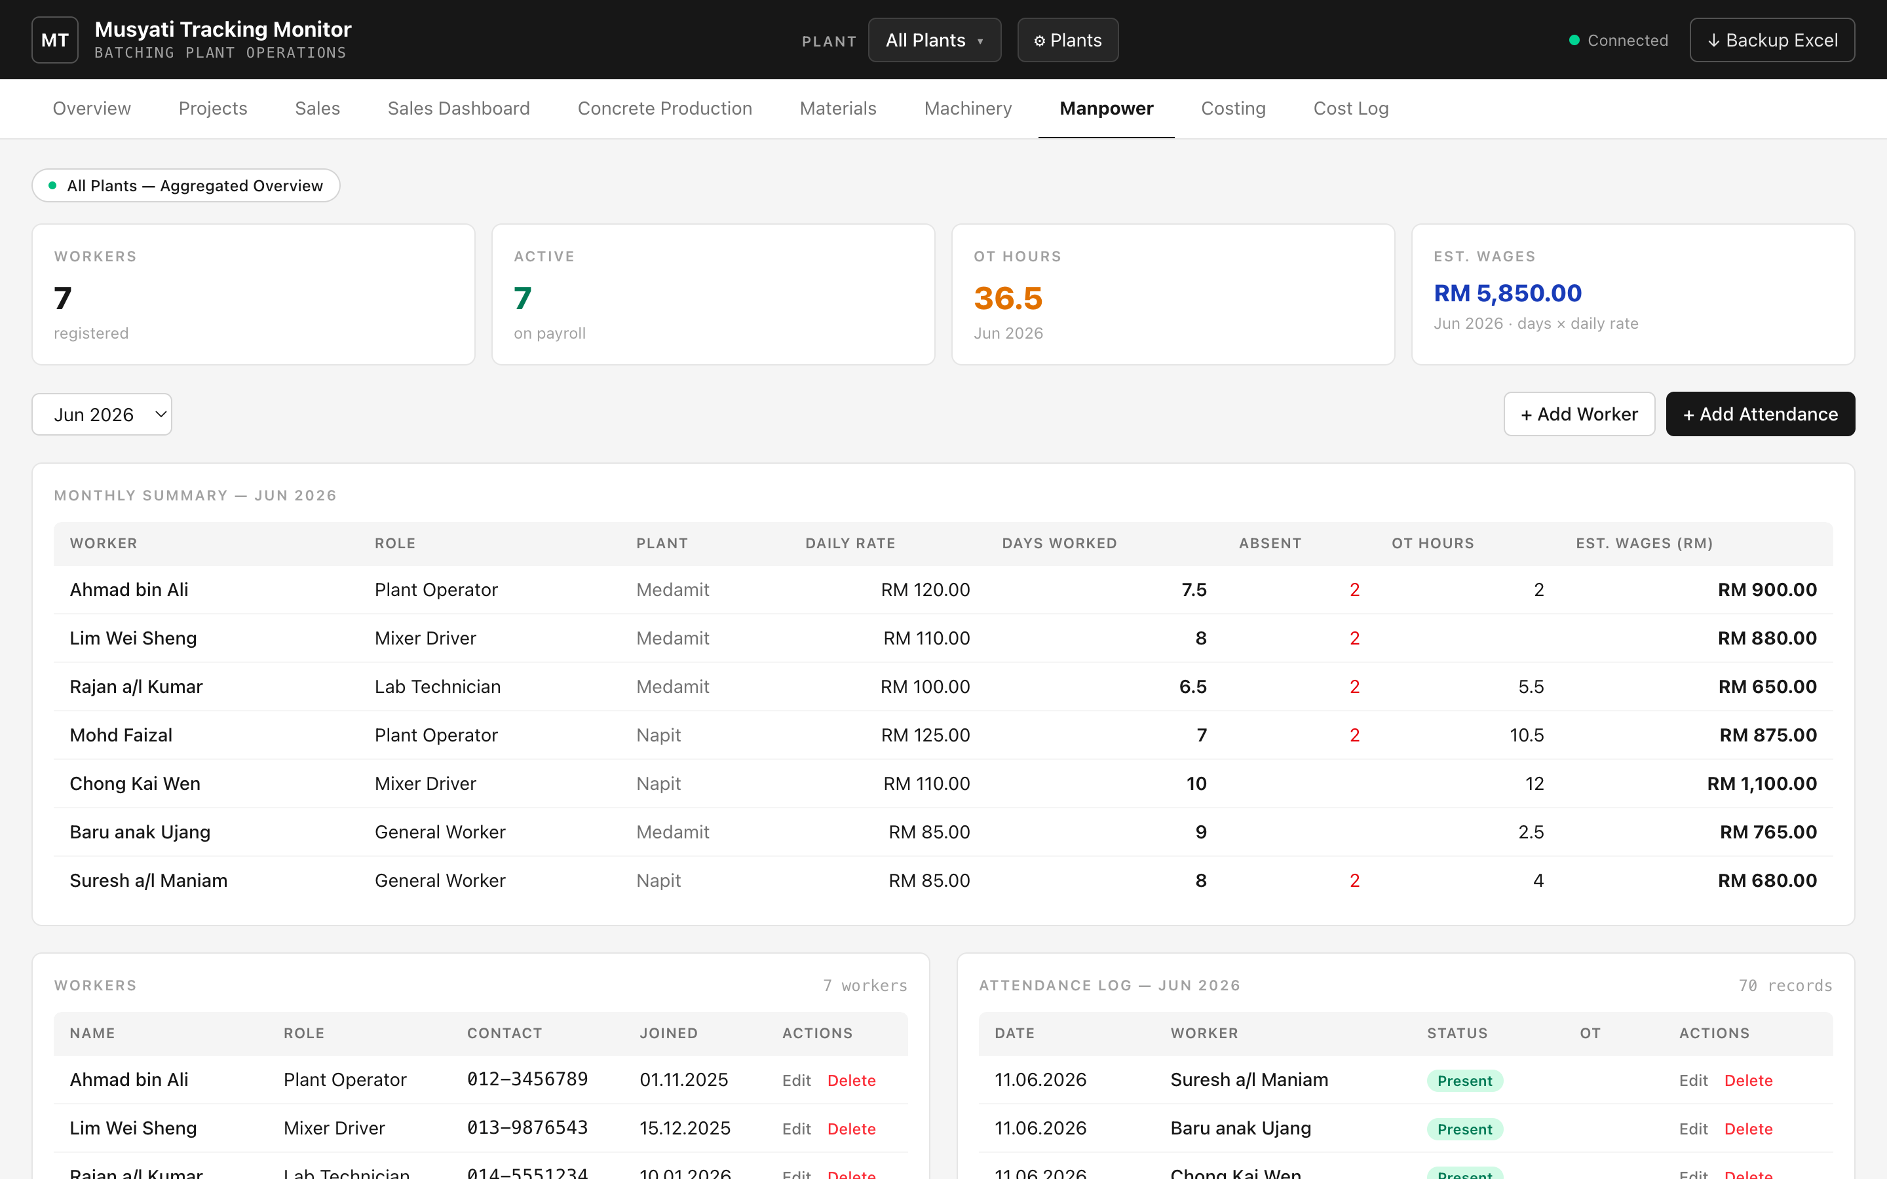
Manpower — monthly wage summary, worker register and attendance log.

12.1 Workers
Add each worker with their role, contact, daily rate and join date. Workers can be marked Active or Inactive.

12.2 Attendance and wages
- Record attendance. Click "+ Add Attendance", pick the worker, date and status (Present / Half Day / Absent), and any overtime hours.
- Monthly Summary. For the chosen month: days worked (Present = 1, Half Day = 0.5), absences, OT hours, and estimated wages = days × daily rate.
- One record per worker per day. The system prevents duplicate attendance for the same worker and date.

13. Costing
A monthly profit-and-loss for a plant, laid out with the twelve months across the top — like the Excel costing sheet, but with the totals computed for you.
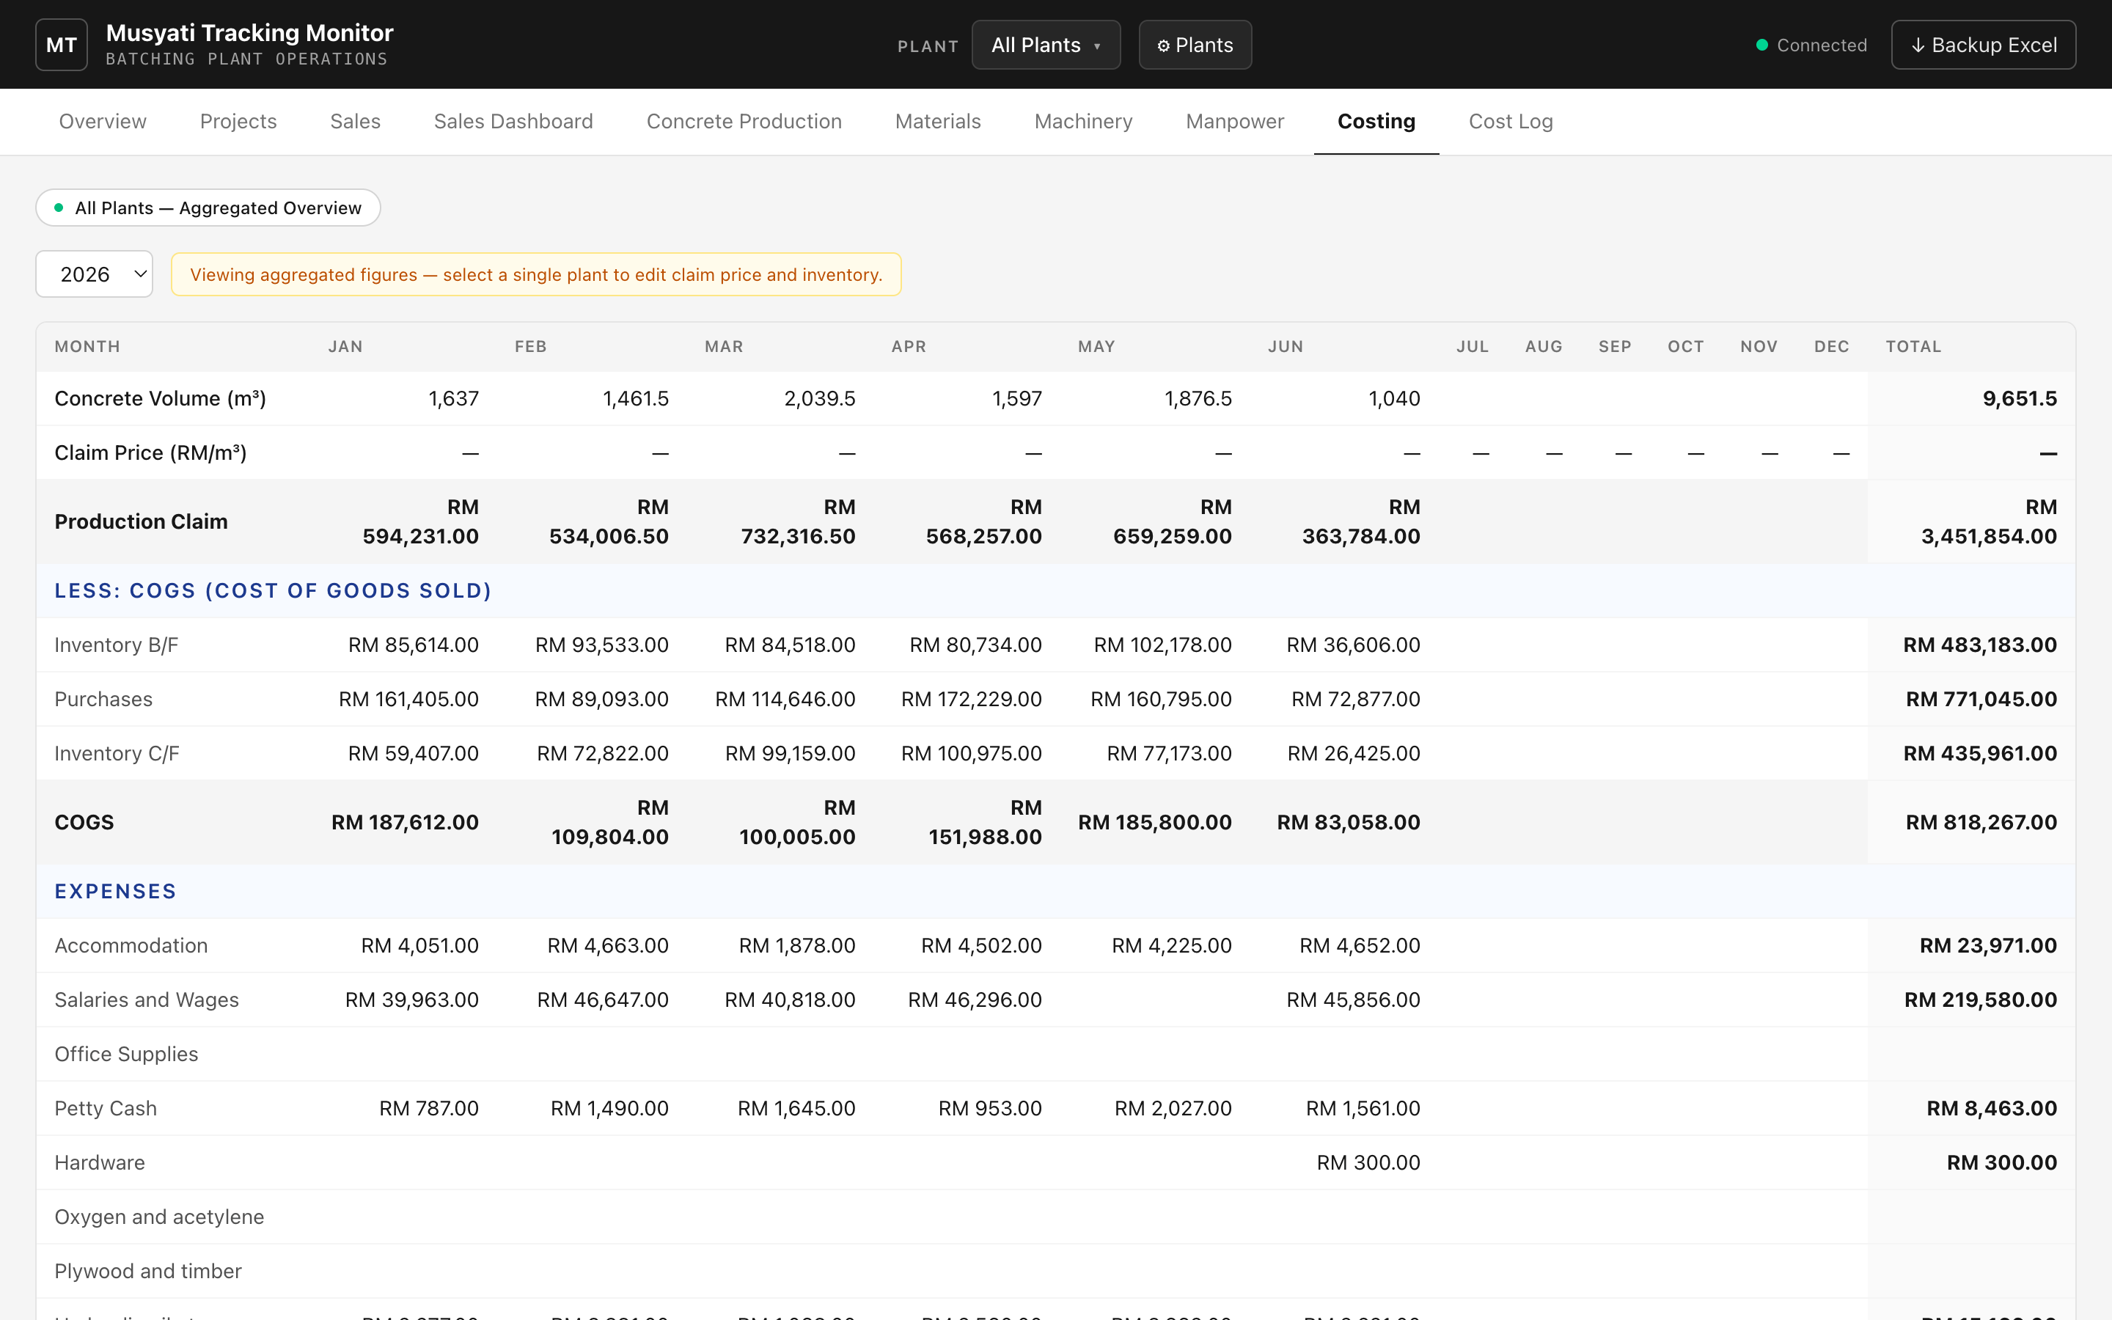
Costing — the monthly profit-and-loss grid.

13.1 What you enter (single plant)
- Claim Price (RM/m³). The market price used to value production. Type it into each month’s cell.
- Inventory B/F, Purchases, Inventory C/F. The three COGS inputs, typed per month.

13.2 What is calculated
Row | Formula
Production Claim | Month’s concrete volume × claim price.
COGS | Inventory B/F + Purchases − Inventory C/F.
Expenses (by category) | Summed automatically from the Cost Log.
Net Income | Production Claim − COGS − Total Expenses.

Tip
Select a single plant to type claim price and inventory figures. "All Plants" shows the combined P&L as read-only.

14. Cost Log
The list of individual expenses. These feed the Expenses rows on the Costing page automatically.
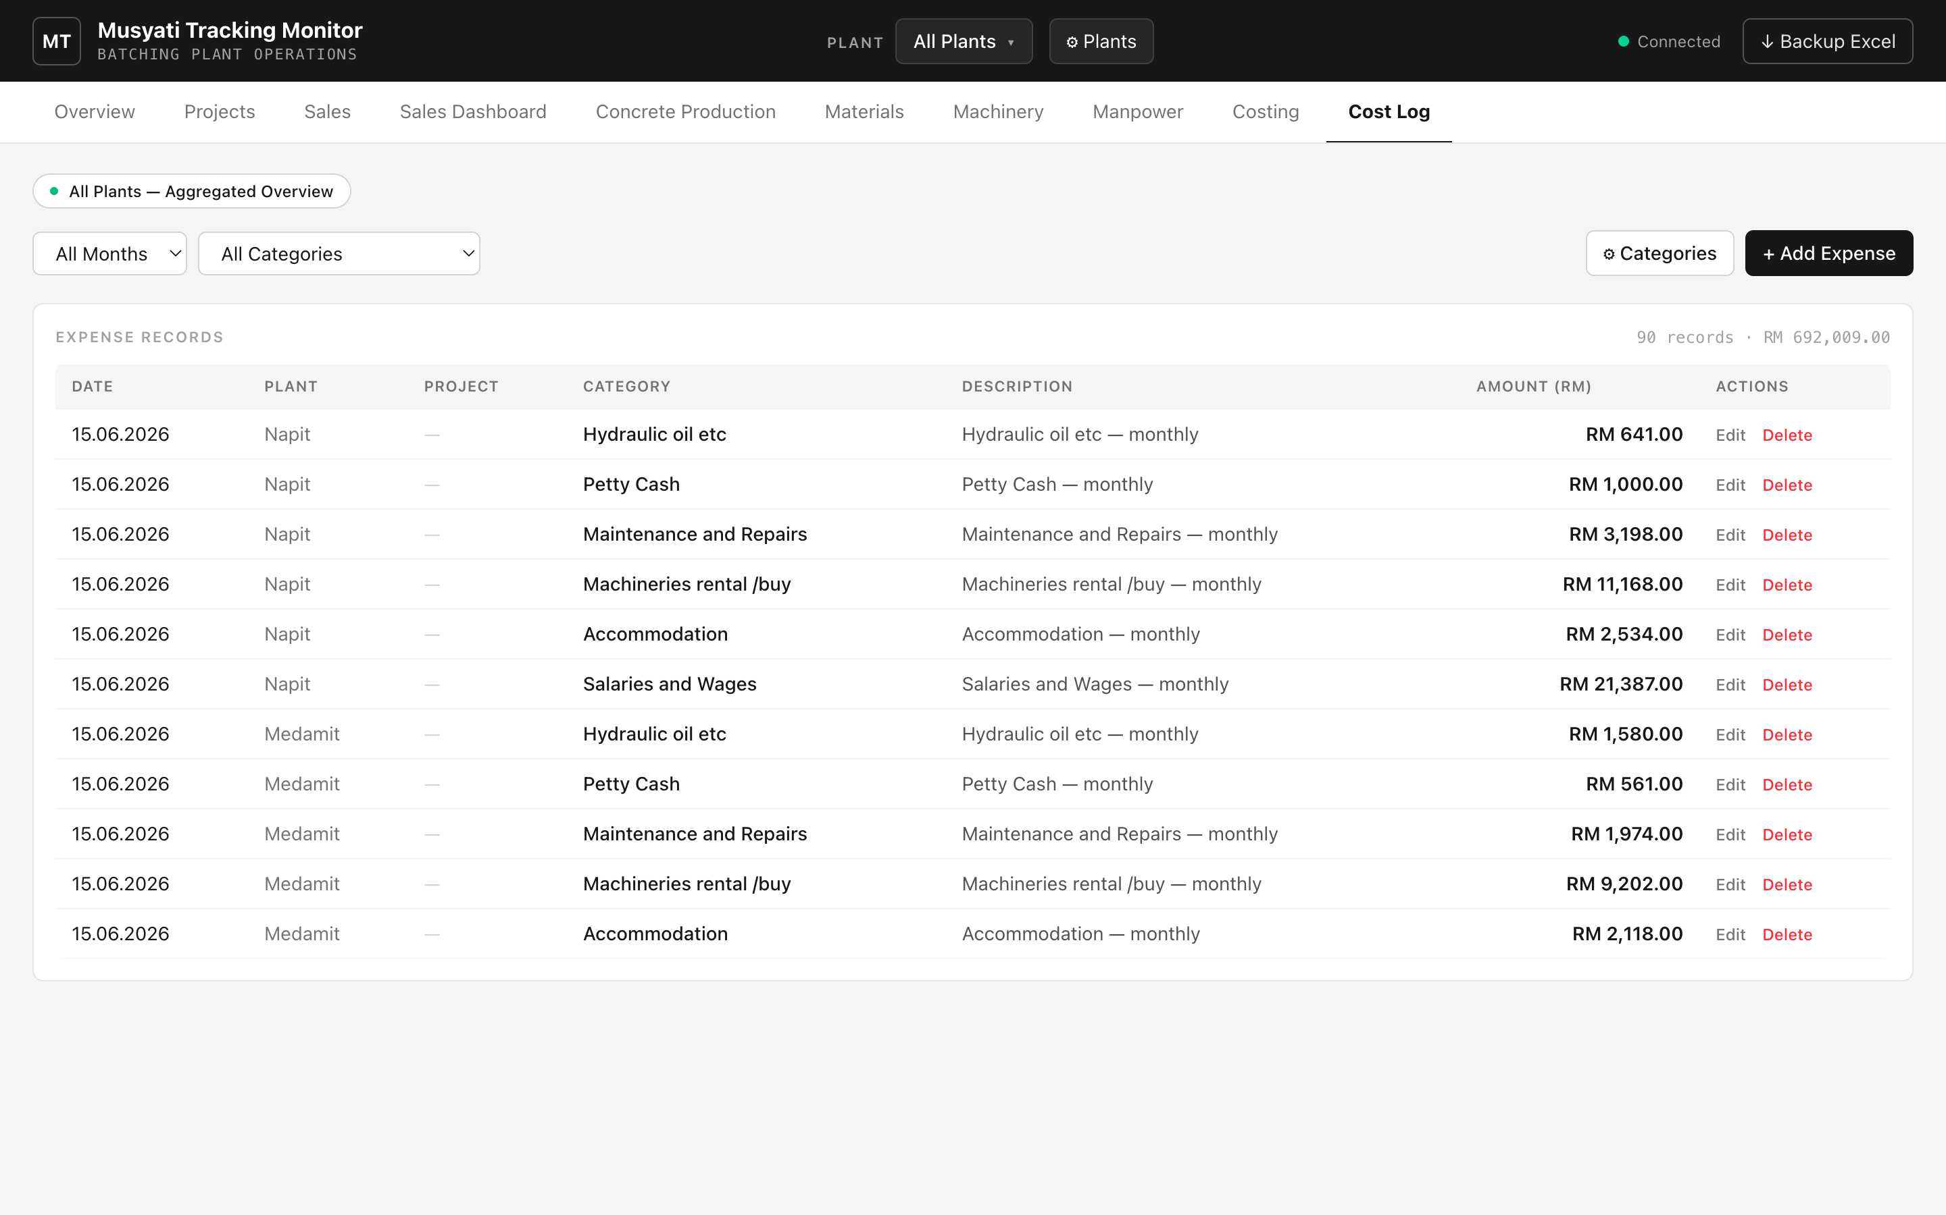
Cost Log — individual expenses, each optionally tagged to a project.

14.1 Adding an expense
- Click + Add Expense.
- Choose plant, date, an optional project, and a category. To create a new category on the spot, pick + New category… and type its name.
- Enter the amount and a description, then save.

14.2 Managing categories
Click ⚙ Categories to add or rename categories. Renaming updates every expense that used the old name. A category in use cannot be deleted until its expenses are reassigned.
Filter the list by month or category; the header shows the count and total for what is displayed.

15. Troubleshooting & FAQ
Symptom | What to do
"Failed to fetch" or amber/red light | The engine window has closed. Re-open it by double-clicking launch-musyati.command.
Browser shows nothing at localhost:4000 | Make sure the black launcher window is open and says the dashboard is running.
Cannot type into the production grid | Select a single plant (not "All Plants") in the header.
Cannot edit claim price in Costing | Select a single plant; the combined view is read-only.
"Cannot delete… still referenced" | Records depend on this item. Remove or reassign them first.
Numbers look off | They are computed from records — check the underlying entries; nothing is typed manually.
macOS blocks the launcher | Right-click the file → Open → Open (one time only).
Need Node.js | If the window says "npm not found", install Node from nodejs.org, then re-launch.

Good habits
- Back up regularly. Click Backup Excel before big edits or at month-end.
- Tag to projects. Tag sales, production and expenses to projects so per-project profit stays meaningful.
- Keep categories tidy. Reuse existing expense categories rather than creating near-duplicates.

Your data is safe and portable
Everything is a normal Excel file at server/data/musyati-data.xlsx. You can open it in Excel to read or archive it, and timestamped backups are kept automatically in the backups folder.

